

Project
Design Implementation

 | Student Number | Surname | First Name
1 | 202402708 | Mokoena | Karabo
2 | 202306895 | Molomo | Karabo
3 | 202420029 | Thabethe | Kamohelo
4 | 202207325 | Thuto | Henderson

TABLE OF CONTENTS
- SCREENSHOTS OR MOCK-UPS FOR EACH SCREEN AND DESCRIPTIONS ............... 3
1.1 Authentication Screen ..................................................... 3
1.2 Dashboards ................................................................. 4
1.3 Driver Dashboard ........................................................ 5
1.4 School Staff Dashboard ................................................ 6
1.5 Nutrition Programme Manager Dashboard .......................... 7
- USER FEEDBACK ...................................................................... 8
2.1 User Scenario Cards ..................................................... 8
2.2 User Feedback Summary Table ....................................... 9
- DESIGN ITERATIONS ................................................................. 10
3.1 Authentication Pages .................................................. 10
3.2 Dashboards .............................................................. 11
3.3 Shared System Features ............................................... 12
- ENTITY RELATIONSHIP DIAGRAM ................................................. 13
- ENTITY DESCRIPTIONS ............................................................ 13
5.1 school table ............................................................ 14
5.2 supplier table .......................................................... 14
5.3 role table ................................................................. 14
5.4 user table ................................................................. 15
5.5 delivery table .......................................................... 15
5.6 fooditem table ......................................................... 15
5.7 inventoryitem table ................................................. 15
5.8 deliveryitem table .................................................. 16
5.9 usagerecord table .................................................. 16
5.10 issue table ............................................................. 16
5.11 alert table ............................................................ 17
5.12 activitylog table .................................................. 17
- RELATIONSHIP JUSTIFICATION .................................................. 18
- TECHNOLOGY CHOICE ............................................................ 19
7.1 Database Justification ................................................. 19
7.2 Justification for Using Django ...................................... 20

1. Screenshots or mock-ups for each screen, and descriptions
1.1 Authentication Screen
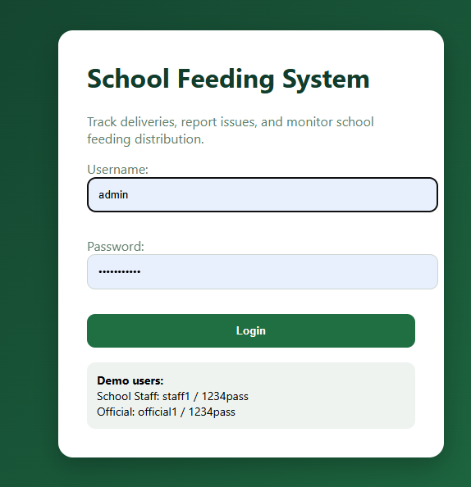

Description:
- The authentication screen allows authorized users to securely access the School Feeding Distribution and Tracking System using administrator-issued credentials. The system uses role-based authentication to direct users to their assigned dashboards based on their roles, such as Delivery Driver, School Staff, or Nutrition Programme Manager. This improves security and prevents unauthorized access to sensitive delivery and inventory data.
- User accounts are created and managed by system administrators. Drivers, school staff, and nutrition programme managers receive login credentials from the administrator instead of registering themselves.

1.2Dashboards
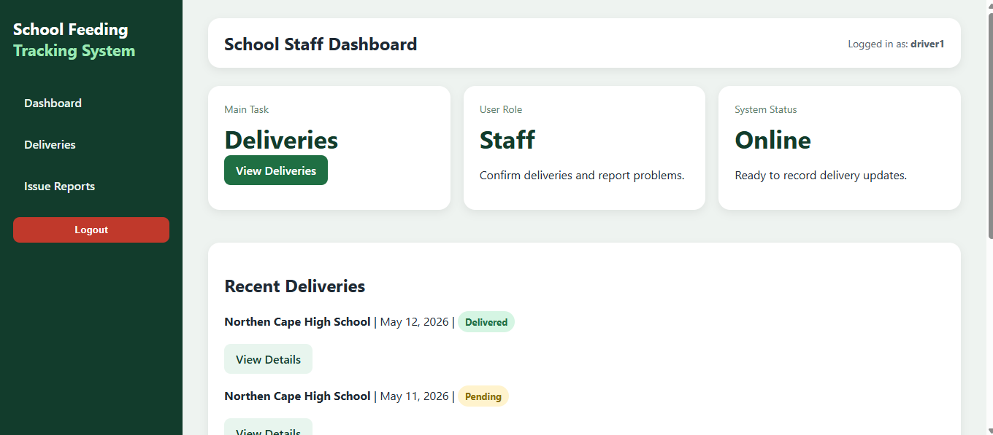
Driver dashboard:
The Delivery Driver Dashboard is designed specifically for delivery personnel responsible for transporting food parcels to schools. The dashboard allows drivers to view assigned deliveries, select destination schools, record delivery information, and submit delivery confirmations. The interface focuses on simplicity and efficiency to support quick data entry during deliveries.
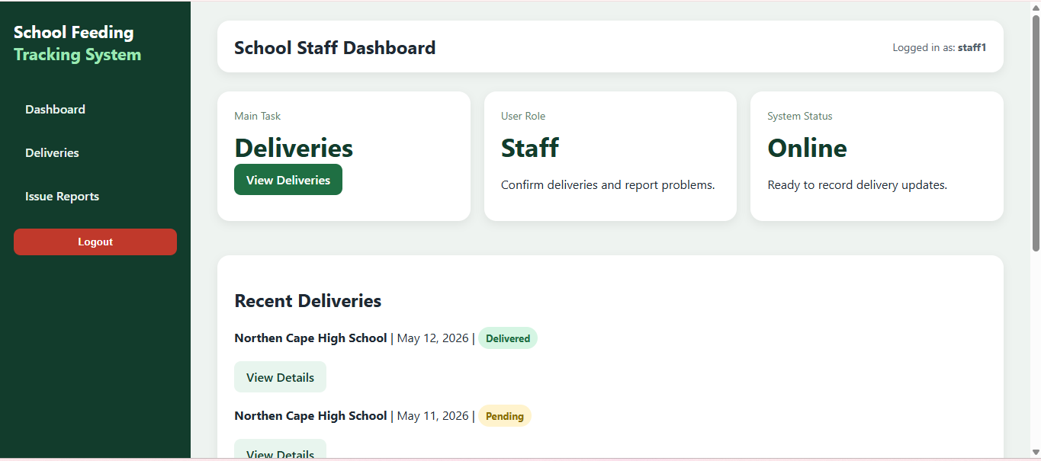
School Staff dashboard:
The School Staff Dashboard allows authorized school personnel to manage food deliveries and inventory at school level. Users can confirm received deliveries, report shortages or damaged items, monitor stock levels, and record daily food usage. The dashboard supports accountability and helps schools maintain accurate food inventory records.
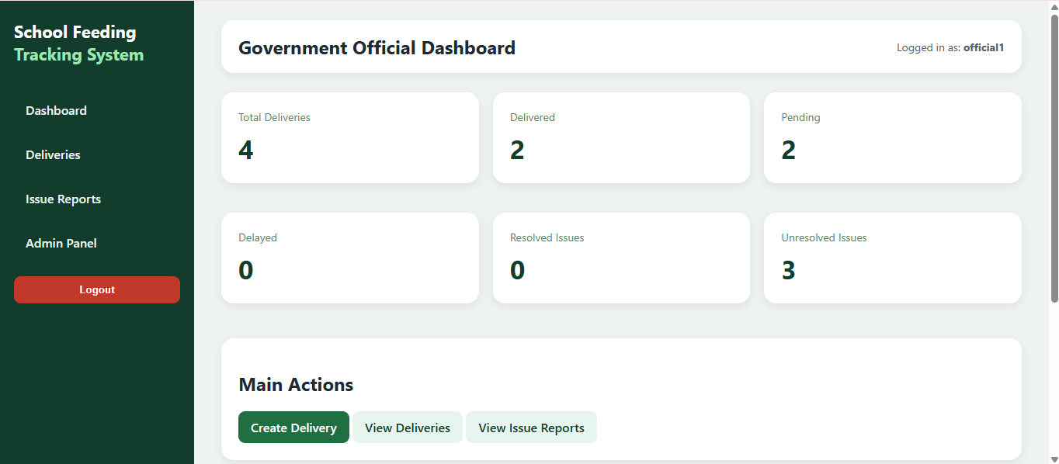
NM Dashbaord:
The Nutrition Programme Manager Dashboard provides centralized monitoring and oversight of the school feeding programme across multiple schools and districts. Managers can track deliveries, monitor reported issues, analyse stock information, and identify delays or discrepancies using reports, summary cards, and visual indicators.

1.3 Driver dashboard
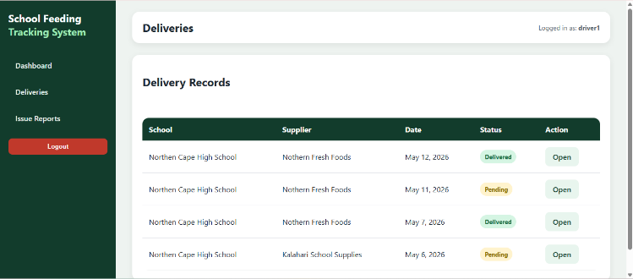
Log Deliveries:
From the dashboard, the driver is able to log food deliveries by selecting the destination school and entering delivery details such as food type and quantity. Once the information is submitted, the system automatically records the delivery date and time and stores the information in the central database for tracking and monitoring purposes.
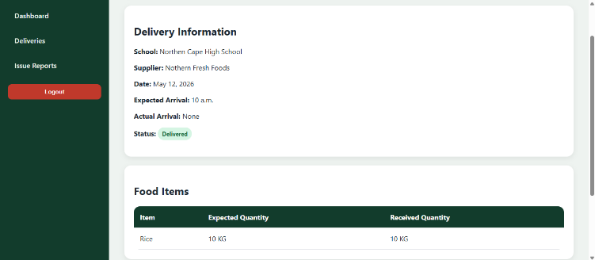
View Delivery Information:
The dashboard also allows drivers to view delivery information, including assigned deliveries, submitted delivery records, and delivery statuses. This helps drivers verify that deliveries have been recorded correctly and provides visibility into completed and pending deliveries.
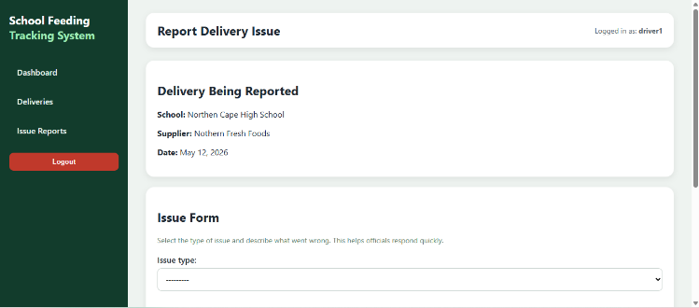
Submit Deliveries & Report Issues:
If a problem occurs during transportation or delivery, the driver can access the Report Issue feature directly from the dashboard. This opens a report form where the driver can enter issue details related to delayed deliveries, damaged goods, or missing stock. Once submitted, the issue is logged into the system and becomes visible to the Nutrition Programme Manager for further investigation and resolution.
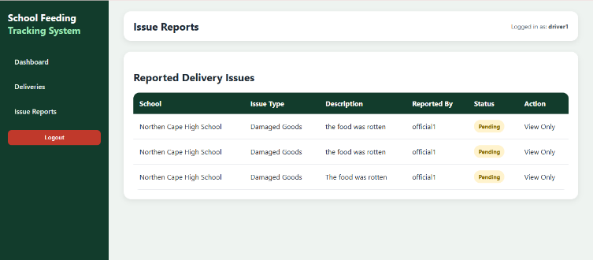
Track Reports:
The driver can also track submitted reports through the dashboard. This allows the driver to monitor the progress and status of previously reported issues, including whether the issue is pending, in progress, or resolved. This feature improves communication, accountability, and transparency within the delivery process.
1.4 School staff Dashboard:
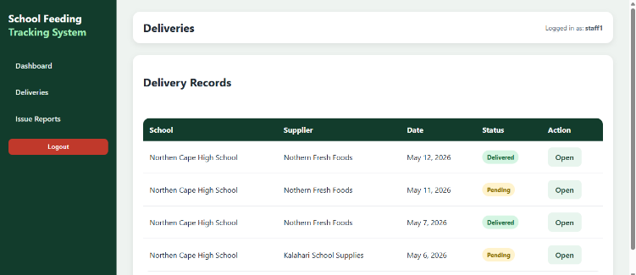
View Deliveries:
From the dashboard, school staff are able to view deliveries made by drivers, including delivery dates, food types, quantities, and delivery statuses. This allows staff members to compare the delivered items with the actual physical stock received at the school. The dashboard also allows users to view detailed delivery information before taking action.
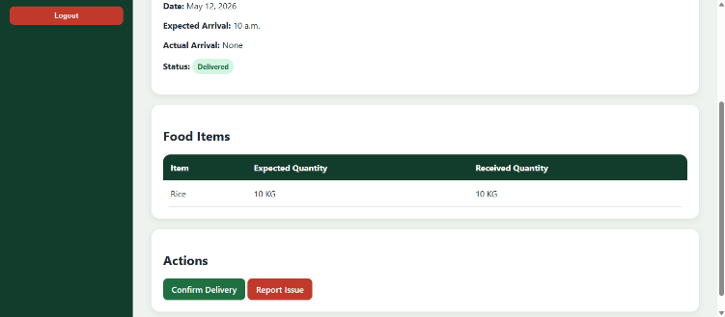
Confirm or Report Delivery:
After reviewing the delivery, school staff can either confirm the delivery if all items are correct or report a problem if there are shortages, damaged goods, missing items, or incorrect quantities

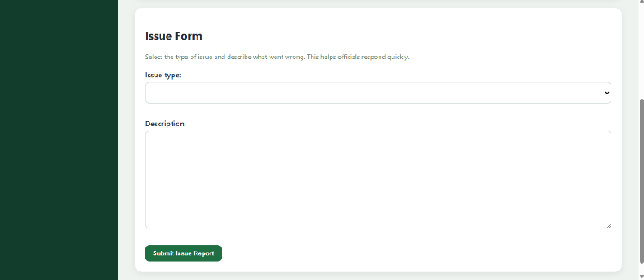
Staff Report Form:
If the user selects the report option, the system opens a report form where issue details can be entered and submitted directly into the system.

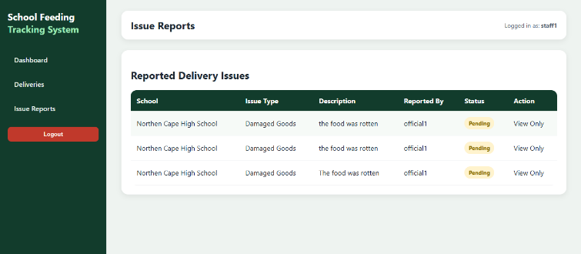
Track Reports
Once submitted, the issue report is automatically logged and becomes visible to the Nutrition Programme Manager for review and investigation. School staff are also able to view and track submitted reports through the dashboard. This allows users to monitor the progress and status of reported issues, including whether the issue is pending, in progress, or resolved.
1.5Nutrition Programme Manager Dashboard
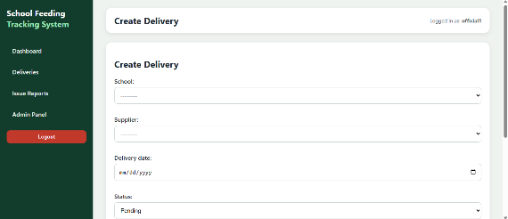
Create delivery:
From the dashboard, the manager is able to create delivery requests and assign them to delivery drivers. During this process, the manager can specify the destination school, food items, quantities, and expected delivery schedules. Once the delivery request is submitted, the assigned driver receives the delivery task through the system.
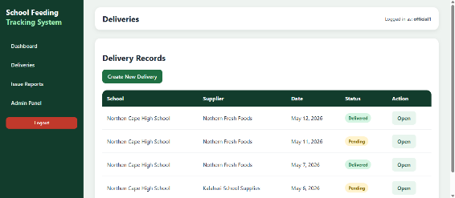
Track Deliveries:
The dashboard also allows managers to track delivery progress in real time. Managers can monitor the status of deliveries, including pending, in transit, delivered, or delayed deliveries. This improves visibility and allows administrators to quickly identify operational problems within the food distribution process.
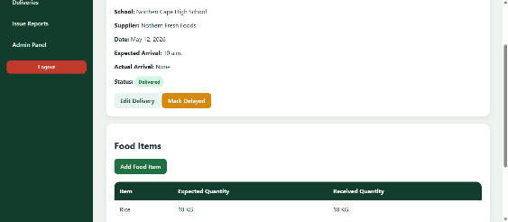
Delivery Info:
Managers are also able to view detailed delivery information for each school. This includes food types, quantities delivered, delivery timestamps, assigned drivers, and confirmation statuses from school staff. If necessary, managers can edit delivery information or manually mark deliveries as delayed when issues occur during transportation or distribution.
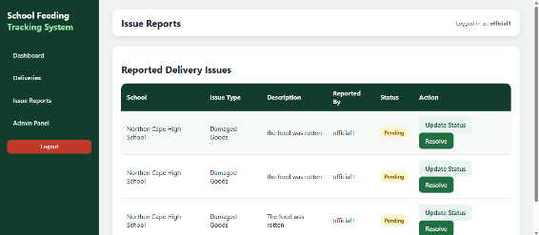
Reported issues:
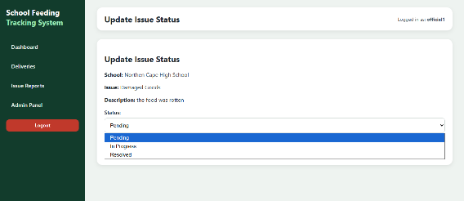
the manager has access to all issue reports submitted by both delivery drivers and school staff. These reports may include delayed deliveries, damaged goods, missing stock, or delivery discrepancies
Update reports:
Managers can review report details, investigate issues, and update the report progress status to pending, in progress, or resolved. This improves communication, transparency, and issue resolution within the programme.
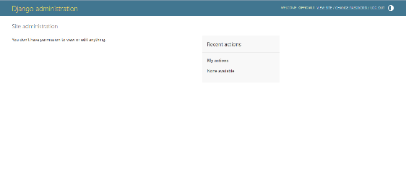
Admin panel page:
The dashboard also includes access to the administration panel, where authorized managers can manage system users. Through this panel, administrators are able to create user accounts, assign roles, authorize system access, manage school and district assignments, and maintain role-based permissions for drivers, school staff, and other managers.
2. User feedback
User feedback was collected through scenario-based evaluation involving three representative users. Each participant interacted with the first prototype of the School Feeding Distribution and Tracking System by performing tasks aligned with their daily responsibilities. The purpose of the evaluation was to identify usability issues, interface limitations, and areas requiring improvement prior to refining the final design.
2.2 User Scenario Cards
▶ Ali | Delivery Driver
USER | Ali
ROLE | Delivery Driver
SCENARIO TASK | Logging deliveries and reporting issues
FEEDBACK OBSERVED | The dashboard lacked a clear visual structure and workload overview. Delivery information was spread across multiple pages, slowing task completion. Buttons and sections appeared too similar, reducing feature discoverability. Issue reporting was limited to text descriptions only — image attachments for damaged parcels were not supported. There was no dedicated notification area for delivery updates or issue progress.

▶ Elisa | School Staff
USER | Elisa
ROLE | School Staff
SCENARIO TASK | Confirming deliveries and reporting shortages
FEEDBACK OBSERVED | Authentication was straightforward, but account creation depended solely on administrator approval, causing access delays for new staff. The delivery list appeared visually crowded with no clear separation between statuses. The issue reporting form lacked guidance, visual clarity, and severity indicators. After confirming a delivery, there was no way to monitor updated inventory or stock quantities. The dashboard felt text-heavy and required improved colour coding and layout.
▶ Alex | Nutrition Programme Manager
USER | Alex
ROLE | Nutrition Programme Manager
SCENARIO TASK | Monitoring deliveries, generating reports, and managing users
FEEDBACK OBSERVED | The dashboard provided delivery and issue access but lacked visual summaries, graphs, and trend indicators needed for large-scale monitoring. Structured report generation was unavailable, requiring manual data collection outside the system. User role assignment was time-consuming, as all access depended on administrative approval. No centralised notification system existed, requiring manual follow-up on delays and issues. Important data appeared in long tables without sufficient visual hierarchy.

2.2User Feedback Summary Table
The table below consolidates the key findings from the scenario-based evaluation across all three users, providing a structured overview of observed usability concerns.
User | Scenario Task | Feedback Observed
Ali (Driver) | Logging deliveries and reporting issues | Dashboard lacked clear workload overview, notifications were not visible, and issue reports could not include attachments or supporting evidence
Elisa (School Staff) | Confirming deliveries and reporting shortages | Delivery information appeared crowded, inventory visibility was limited, and the interface lacked colour distinction and visual clarity
Alex (Manager) | Monitoring deliveries, generating reports, and managing users | Dashboard lacked graphs and analytics, report generation was unavailable, notifications were limited, and user role assignment created administrative burden

3. Design iterations
3.1 Authentication Pages
The system includes dedicated registration and login pages that provide secure access to the School Feeding Distribution and Tracking System.

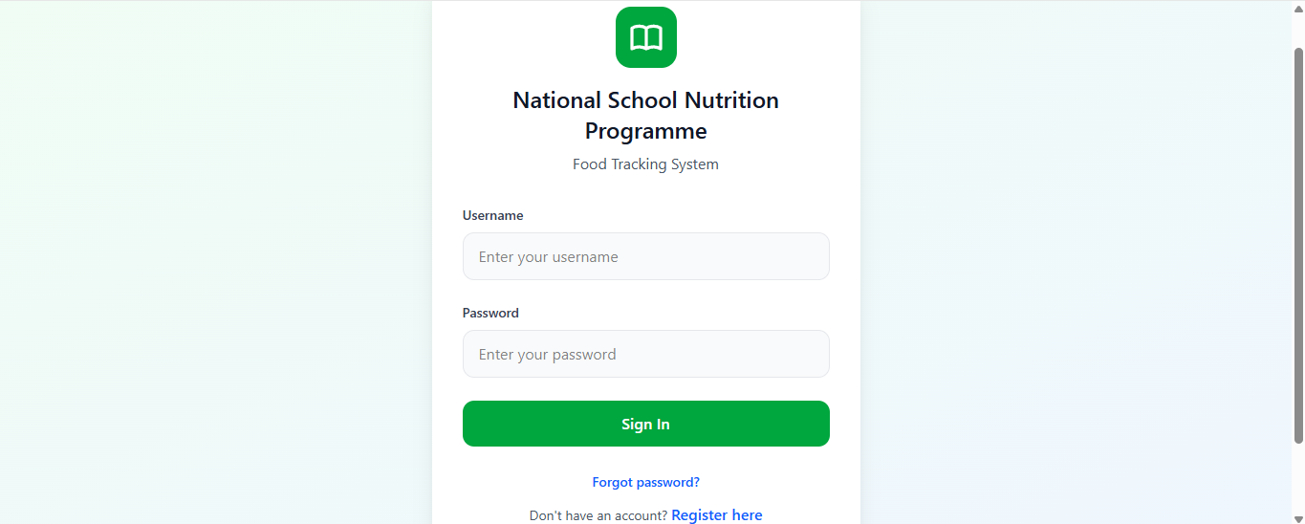
Login page:
Unlike the initial prototype where user accounts were manually created by administrators, the improved system allows users to register themselves by selecting their role during the registration process. Available roles include Delivery Driver, School Staff, and Nutrition Programme Manager.

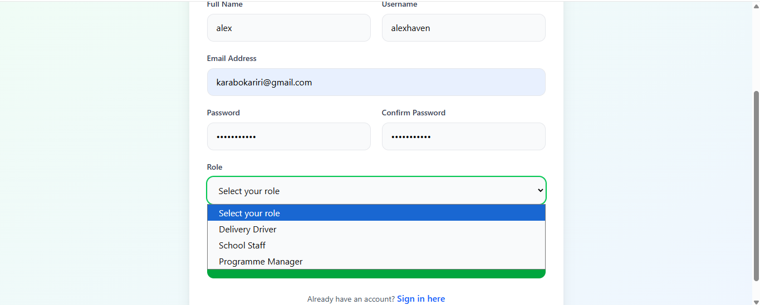
Registration page:

This self-registration approach reduces the administrative burden of manually creating accounts and issuing login credentials to users across multiple schools and districts. During registration, users are required to enter relevant personal and authentication information before gaining access to the system.
Once registered, users can securely log into the system using their credentials. The system then authenticates the user and redirects them to their designated role-based dashboard. The authentication pages were designed with a clean and user-friendly interface to improve accessibility, simplify onboarding, and enhance the overall user experience.

3.2 Dashboards
The system consists of three role-based dashboards designed for Delivery Drivers, School Staff, and Nutrition Programme Managers. Each dashboard provides users with access to functions relevant to their responsibilities within the School Feeding Distribution and Tracking System.

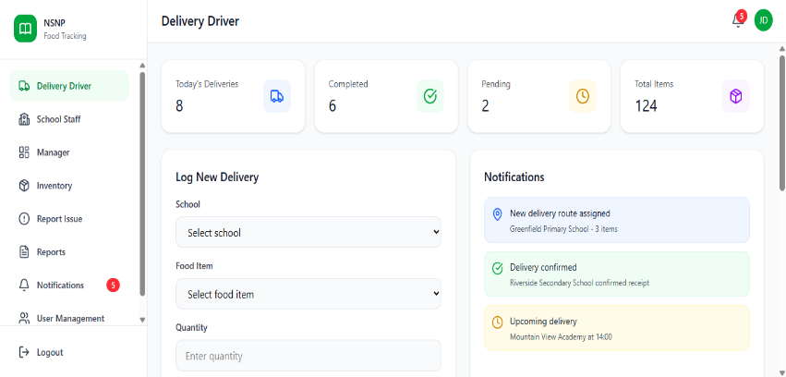
Redesigned Driver Dashboard:

The Delivery Driver Dashboard allows drivers to manage food deliveries by logging delivery details, viewing delivery history, tracking delivery progress, receiving notifications, and reporting delivery-related issues with supporting attachments. The dashboard also provides real-time summaries such as completed, pending, and total deliveries.

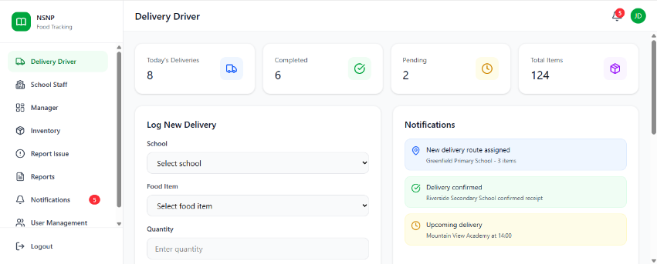
School staff Dashboard:

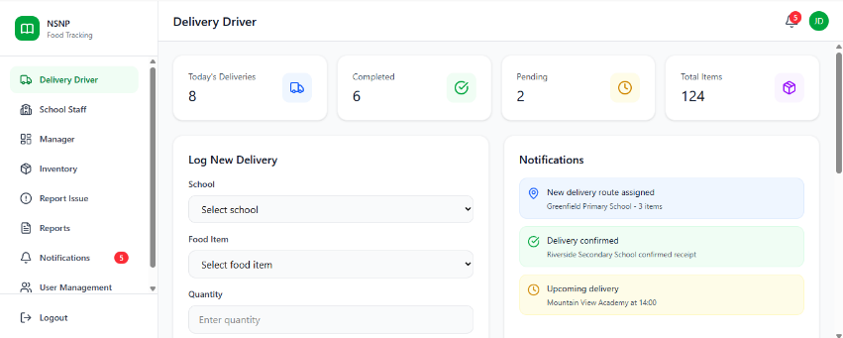
The School Staff Dashboard enables school personnel to verify incoming deliveries, confirm received stock, report discrepancies, and monitor submitted reports. Users can access detailed delivery information, track issue statuses, and view inventory-related data linked to school deliveries.

NM Programme Dashbaord

The Nutrition Programme Manager Dashboard provides centralized monitoring and administrative control across multiple schools and districts. Managers can track deliveries, monitor delays, generate reports, analyse delivery and inventory data, and oversee reported issues. The dashboard also includes a user management section where managers can create accounts, assign user roles, manage permissions, and control system access.

*All dashboards share integrated features such as notifications, reporting tools, inventory visibility, and role-based access control to improve accountability, transparency, and operational efficiency within the feeding programme.

3.3 Shared System Features (All Dashboards)
All dashboards within the system share several core features to ensure consistency and integration across user roles.
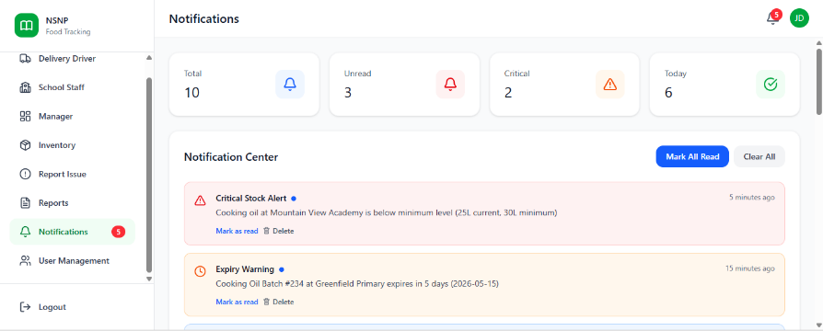
These include:
- Real-time notifications for system updates

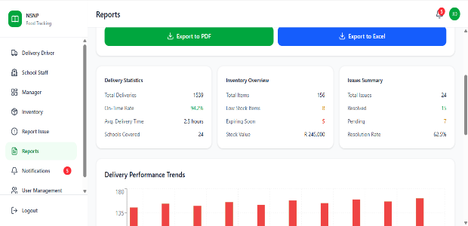
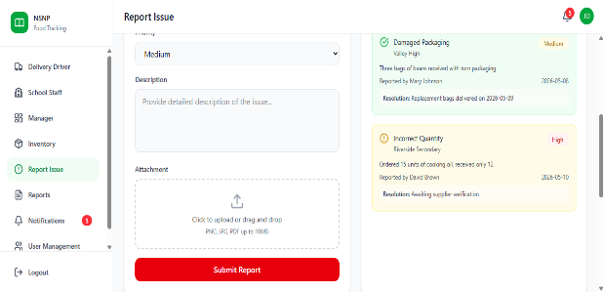
Access to reporting systems for logging and tracking issues:
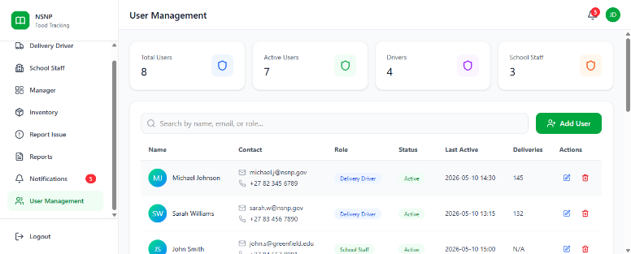
Centralised data storage for deliveries, inventory, and reports:
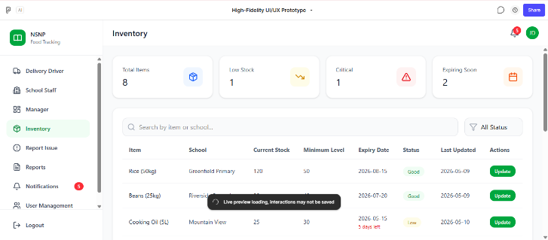

Role-based access control ensuring users only access relevant features

These shared features ensure that all users operate within a connected system that supports transparency and efficient communication.
4. Entity Relationship Diagram
  - 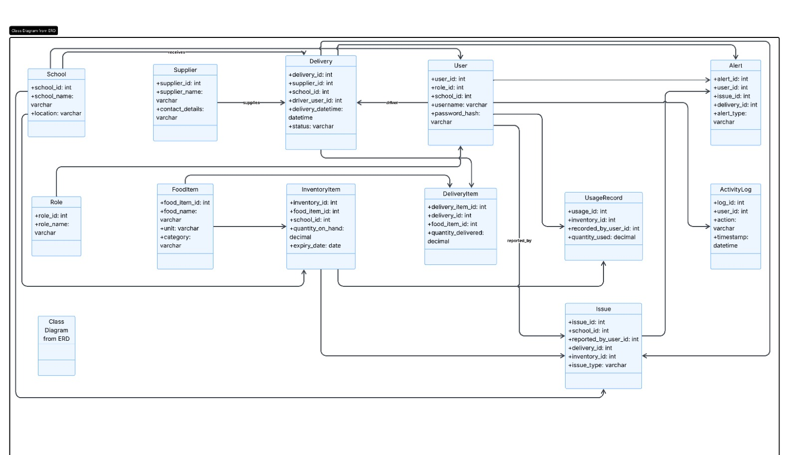

5. Entity Descriptions

SCHOOL Table - Stores information about schools participating in the nutrition programme.
Field Name | Description | Data Type | Length
school_id | Unique school identifier | INT | 11
school_name | School name | VARCHAR | 100
location | School location | VARCHAR | 255

SUPPLIER Table - Stores supplier information for tracking food providers.
Field Name | Description | Data Type | Length
supplier_id | Unique supplier identifier | INT | 11
supplier_name | Supplier name | VARCHAR | 100
contact_details | Supplier contact details | VARCHAR | 255

ROLE Table - Defines system roles such as Driver, School Staff, and Manager.
Field Name | Description | Data Type | Length
role_id | Unique role identifier | INT | 11
role_name | User role name | VARCHAR | 50

USER Table - Stores login credentials and role information for all system users.
Field Name | Description | Data Type | Length
user_id | Unique user identifier | INT | 11
role_id | Linked role | INT | 11
school_id | Linked school | INT | 11
username | Login username | VARCHAR | 50
password_hash | Encrypted password | VARCHAR | 255

DELIVERY Table - Stores all food delivery records and delivery statuses.
Field Name | Description | Data Type | Length
delivery_id | Unique delivery identifier | INT | 11
supplier_id | Linked supplier | INT | 11
school_id | Linked school | INT | 11
driver_user_id | Assigned driver | INT | 11
delivery_datetime | Delivery date and time | DATETIME | -
status | Delivery status | VARCHAR | 50

FOODITEM Table - Stores food item details used throughout the system.
Field Name | Description | Data Type | Length
food_item_id | Unique food item identifier | INT | 11
food_name | Food item name | VARCHAR | 100
unit | Measurement unit | VARCHAR | 20
category | Food category | VARCHAR | 50

INVENTORYITEM Table - Tracks current stock levels and expiry dates at schools.
Field Name | Description | Data Type | Length
inventory_id | Unique inventory identifier | INT | 11
food_item_id | Linked food item | INT | 11
school_id | Linked school | INT | 11
quantity_on_hand | Available quantity | DECIMAL | 10,2
expiry_date | Expiry date | DATE | -

DELIVERYITEM Table - Links deliveries with multiple food items and quantities delivered.
Field Name | Description | Data Type | Length
delivery_item_id | Unique delivery item identifier | INT | 11
delivery_id | Linked delivery | INT | 11
food_item_id | Linked food item | INT | 11
quantity_delivered | Delivered quantity | DECIMAL | 10,2

USAGERECORD Table - Records daily food usage within schools.
Field Name | Description | Data Type | Length
usage_id | Unique usage identifier | INT | 11
inventory_id | Linked inventory item | INT | 11
recorded_by_user_id | User recording usage | INT | 11
quantity_used | Quantity used | DECIMAL | 10,2

ISSUE Table - Stores reported issues such as missing, delayed, or damaged deliveries.
Field Name | Description | Data Type | Length
issue_id | Unique issue identifier | INT | 11
school_id | Linked school | INT | 11
reported_by_user_id | Reporting user | INT | 11
delivery_id | Linked delivery | INT | 11
inventory_id | Linked inventory | INT | 11
issue_type | Type of issue | VARCHAR | 50

ALERT Table - Stores automated alerts and notifications generated by the system.
Field Name | Description | Data Type | Length
alert_id | Unique alert identifier | INT | 11
user_id | Receiving user | INT | 11
issue_id | Linked issue | INT | 11
delivery_id | Linked delivery | INT | 11
alert_type | Alert type | VARCHAR | 50

ACTIVITYLOG Table - Stores audit logs for accountability and monitoring.
Field Name | Description | Data Type | Length
log_id | Unique log identifier | INT | 11
user_id | User performing action | INT | 11
action | Action performed | VARCHAR | 255
timestamp | Action timestamp | DATETIME | -

6. Relationship Justification

Relationship | Type | Justification
ROLE → USER | One-to-Many (1:M) | One role can belong to many users.
SCHOOL → USER | One-to-Many (1:M) | One school can have many users.
SUPPLIER → DELIVERY | One-to-Many (1:M) | One supplier can create many deliveries.
SCHOOL → DELIVERY | One-to-Many (1:M) | One school can receive many deliveries.
USER → DELIVERY | One-to-Many (1:M) | One driver can record many deliveries.
DELIVERY → DELIVERYITEM | One-to-Many (1:M) | One delivery can contain many food items.
FOODITEM → DELIVERYITEM | One-to-Many (1:M) | One food item can appear in many deliveries.
SCHOOL → INVENTORYITEM | One-to-Many (1:M) | One school can store many inventory items.
FOODITEM → INVENTORYITEM | One-to-Many (1:M) | One food item can exist in many inventory records.
INVENTORYITEM → USAGERECORD | One-to-Many (1:M) | One inventory item can have many usage records.

7. Technology choice

7.1 Database Justification
For the prototype, SQLite was selected because it is lightweight, easy to configure, and built into Django by default. Since the current project is a prototype, the main focus is to demonstrate usability, navigation, user interaction, and core system functionality rather than large-scale performance. SQLite allows the system to store sample data such as schools, suppliers, deliveries, food items, users, and issue reports without requiring complex database installation or server configuration. This makes it suitable for fast development, testing, and demonstration.
For the production version, the system would be upgraded to MySQL because it is more suitable for a larger, real-world deployment. The School Feeding Distribution and Tracking System may eventually support many schools, suppliers, delivery drivers, and government officials using the system at the same time. MySQL provides better support for concurrent users, stronger data management, improved scalability, user permissions, backups, and long-term reliability. This makes it more appropriate for handling real operational data in a live environment.
Therefore, SQLite is suitable for the prototype stage because it supports quick development and testing, while MySQL is more appropriate for the production stage because it can support growth, multiple users, and reliable large-scale data management.
Justification for Using Django
Django was selected as the framework for developing the final School Feeding Distribution and Tracking System because it provides a secure, scalable, and structured environment for building web applications. The system requires functionality such as user authentication, role-based access control, delivery management, issue reporting, dashboards, and database integration, all of which are well supported by Django.
One of the main reasons for choosing Django is that it follows the Model-View-Template (MVT) architecture, which helps organize the system into separate components for data management, business logic, and user interface design. This makes the system easier to develop, maintain, and expand in the future.

7.2 Django also includes built-in features such as:
- user authentication and login management,
- admin dashboard functionality,
- form handling and validation,
- database integration,
- URL routing,
and security protection against common web vulnerabilities.
These built-in tools reduce development time and improve system reliability.
The framework is also suitable for the project because the system has multiple user roles, including:
- school staff,
- delivery drivers,
- and government officials.
Django makes it easier to manage permissions and dashboards for different users.
Another advantage is that Django integrates well with databases such as SQLite during development and MySQL in production. This supports the transition from a prototype system to a fully deployed production system.
From an HCI perspective, Django also supports rapid interface development, allowing the prototype to focus on:
- usability,
- navigation,
- feedback mechanisms,
- learnability,
- and task efficiency.
Therefore, Django is an appropriate choice for the final system because it supports both the technical requirements and the usability goals of the School Feeding Distribution and Tracking System.

